## horizontal line



#Task-1

**─**

C. Janith kumar reddy

CS24B1104

## Project-1:-

Automatic Curtains.

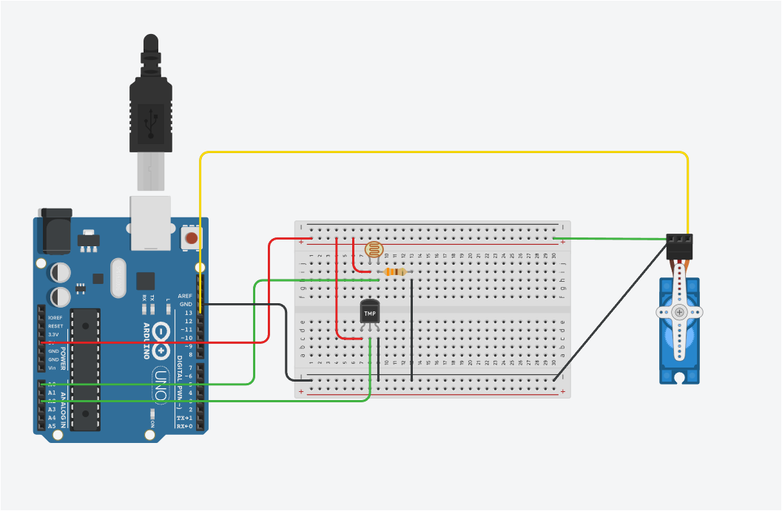

Video link:- [Automatic Curtains video.mp4](https://drive.google.com/file/d/1hOKYnBXFKVAl4TAuDl2Lnp4iUmoy1SRf/view?usp=drive_link)

# Components

| Name | Quantity |
| --- | --- |
| Arduino Uno Rs | 1 |
| 330 ohm Resistor | 1 |
| Photoresistor | 1 |
| Temperature Sensor[TMP36] | 1 |
| Servo | 1 |

# Working

Controls the position of the Curtain.

* When the Light is too bright (i.e value above 300) the curtains will close.
* When the temperature is high (ie above 30) the curtains will close.
* When the temperature is low(i.e below 10) the curtains will close.
* In all other cases it stays open.

## Project 2:-

Anti-Theft Alarm.

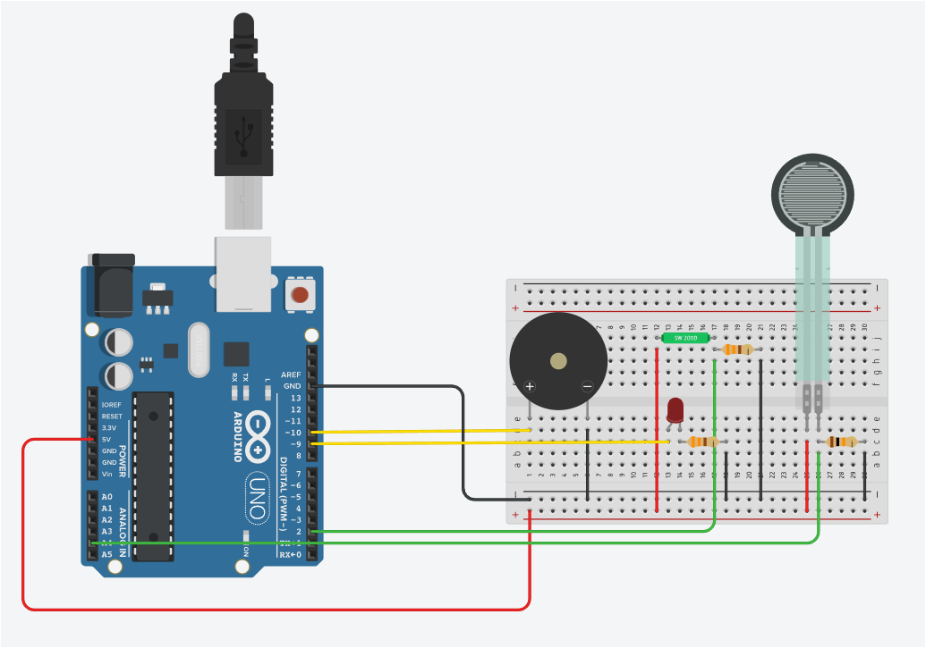

Video link:- [Anti-theft alarm video.mp4](https://drive.google.com/file/d/1TmEQl8XaRm9g3-z3pSrizshbFLFX4DEG/view?usp=drive_link)

# Components

| Name | Quantity |
| --- | --- |
| Arduino Uno Rs | 1 |
| 330 ohm Resistor | 2 |
| Piezo | 1 |
| Tilt sensor | 1 |
| 10K ohm Resistor | 1 |
| Force sensor | 1 |
| Red LED | 1 |

# Working

This alarm secures an object placed based on the position of the object and the weight of the object(Assuming that the weight of the object is 5 units.).

* When the object is tilted from its original position, LED light will glow indicating that the object has been moved from the original position.
* When the object is removed from position then the Buzzer and LED glows indicating that the object has been removed from the position.
* When the object is replaced by another object with different weight the LED glows and the sound buzzes indicating that the object has been replaced by another object.

## Project 3:-

Automatic door (In shopping malls).

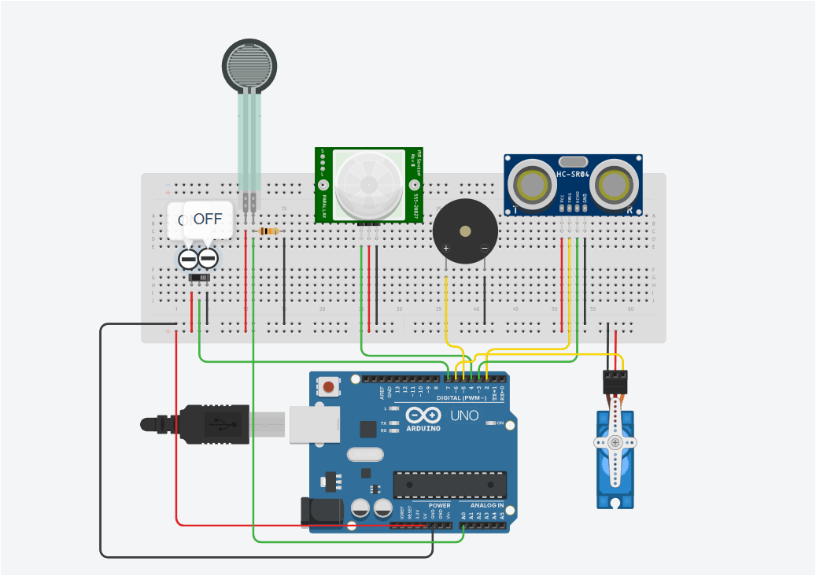

Video link:- [Automatic door (In shopping malls) video.mp4](https://drive.google.com/file/d/1uzfaPlOKqnf7EQws7QCMdkJEGsX-lBOM/view?usp=drive_link)

# Components

| Name | Quantity |
| --- | --- |
| Arduino Uno Rs | 1 |
| PIR sensor | 1 |
| Piezo | * 1 |
| Ultrasonic Distance sensor(4-pin) | 1 |
| 10K ohm Resistor | 1 |
| Force sensor | 1 |
| servo | 1 |
| Slide Switch | 1 |

# Working

This Automatic door opens when it senses a person walking and closes after a time delay. Only when the slide switch is ON, but when the slide switch is OFF then it acts as a security door, i.e if there are any forceful attempts then the Buzzer starts beeping indicating intrusion.

When slide switch is ON:-

* When the person is 100 cm away from the door and has motion then the PIR sensor detects and opens the door.
* When the person is standing in front of the door without any motion then the door stays open.

When slide switch is OFF:-

* When a person tries to forcefully open the door then the alarm starts beeping alerting the intrusion.